Enterprise Integration Platform

***JMeter setup and usage***

Table of Contents

1. Purpose 3

2. Download and start JMeter 3

2.1. Download JMeter 3

2.2. Start JMeter 3

3. Create test plan 5

3.1. Create Thread Group 5

3.2. Create HTTP Request 7

3.3. Add Listener 8

4. Perform load testing 9

## Purpose

This document is a step by step explanation for how to perform load and performance testing for rest apis.

## Download and start JMeter

## Download JMeter

[jmeter download page](https://jmeter.apache.org/download_jmeter.cgi) and download. I have used the below highlighted zip file.

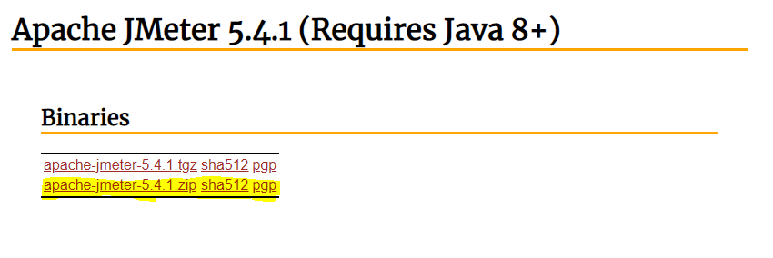

## Start JMeter

To run the jmeter, go to the folder the /jmeter/bin and run **jmeter.bat** file.

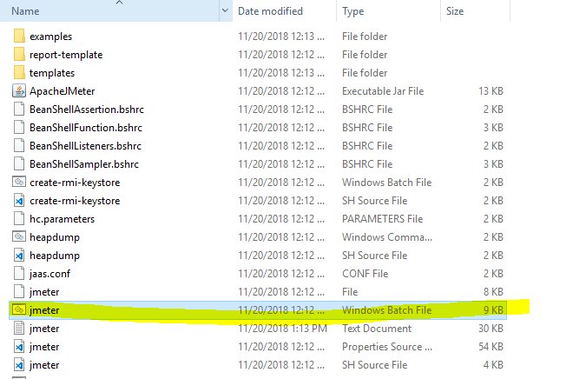

It will start the JMeter UI with no test plan initially. Now, it is time to create a test plan for our rest api load testing.

JMeter initial screen

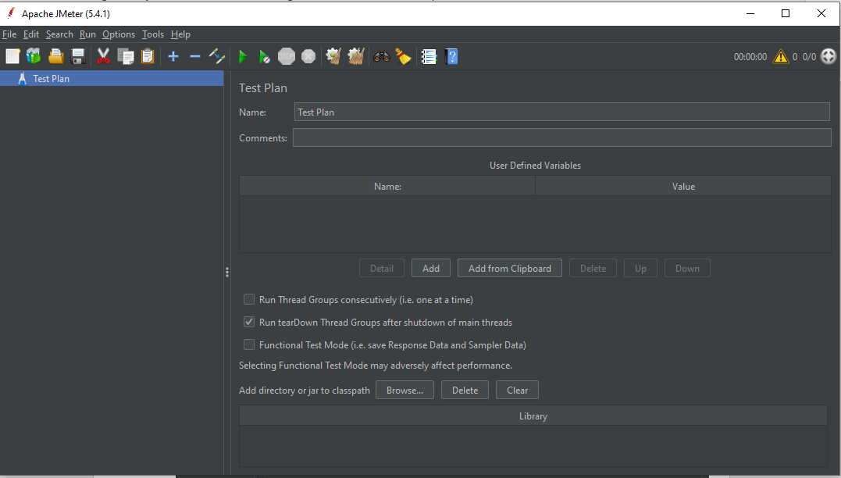

### 2.2.1 Skip SSL Validation

* Open property file /jmeter/bin/jmeter.properties
* Search for server.rmi.ssl.disable=false and remove # to uncomment it
* Restart Jmeter if already running

### 2.2.2 Installing Plugin Manager

* Go to URL <https://jmeter-plugins.org/install/Install/>
* Follow instructions under Installing Plugins title

## Create test plan

A useful test plan is created with minimum 3 components –

* **Thread Group** – contains the simulation of multiple concurrent users. A single thread represents a single user. We can create any number of threads to put the desired load on the application. It also helps us in scheduling the delay between two threads, and any repetition of request batches.
* **HTTP Request** – HTTP request configuration which thread group will be invoking. It is the application URL which you want to load test.
* **Listener** – helps in viewing the result of the whole testing process. There is multiple listener available in JMeter to verify the testing results.

## Create Thread Group

To create a thread group, navigate to *‘Right click Test Plan -> Add -> Threads -> Thread Group’*.

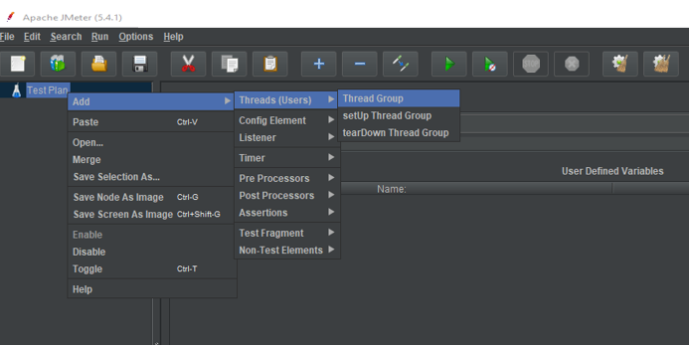

Create Thread Group Option

Fill in the values as per your requirements (or based on your assumptions, we can change them anytime in future). Name the thread group and save it to any location in your workstation.

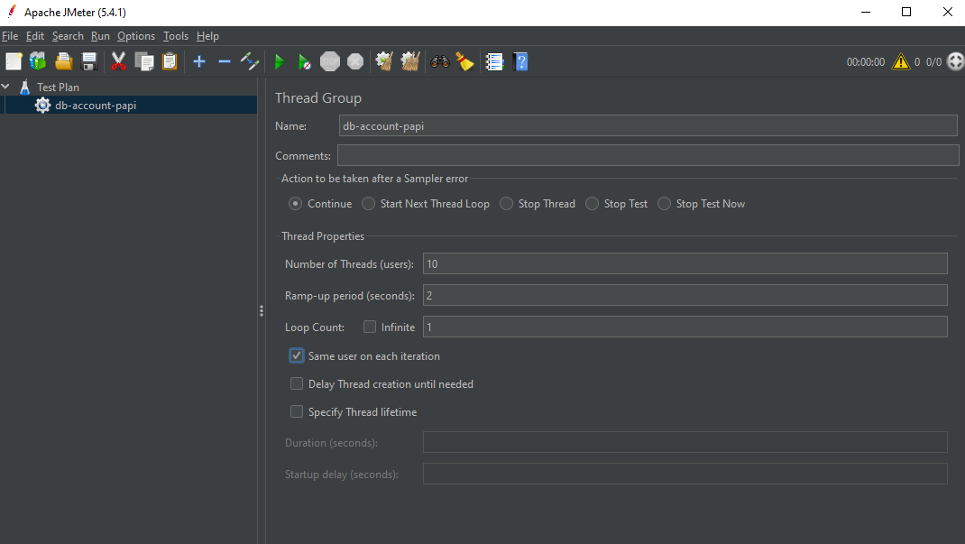

Thread Group Created

## Create HTTP Request

To add HTTP request details, navigate to *‘Right click thread group -> Add -> Sampler -> HTTP Request’*.

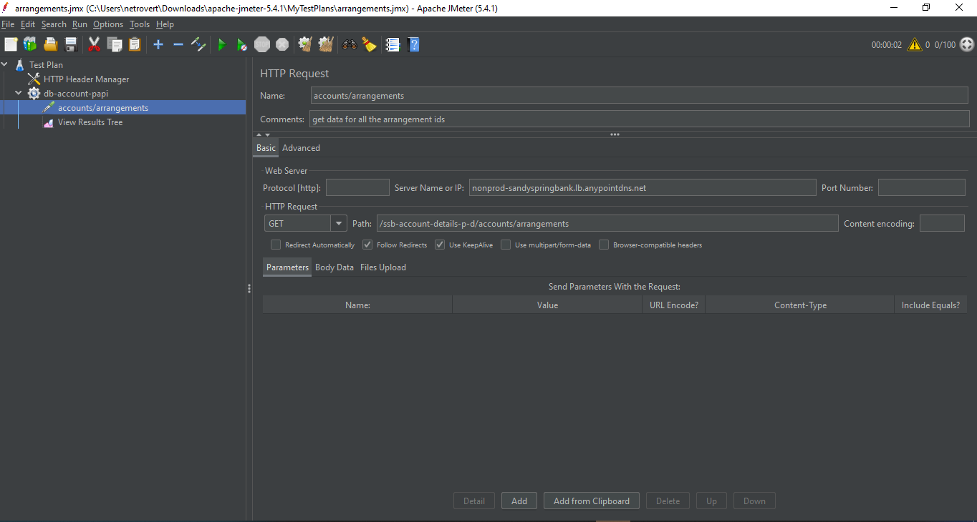

### 3.2.1 Adding Proxy configuration

To add HTTP request details, navigate to *‘Right click Http Request -> Add -> Config Element-> HTTP Header manager*.

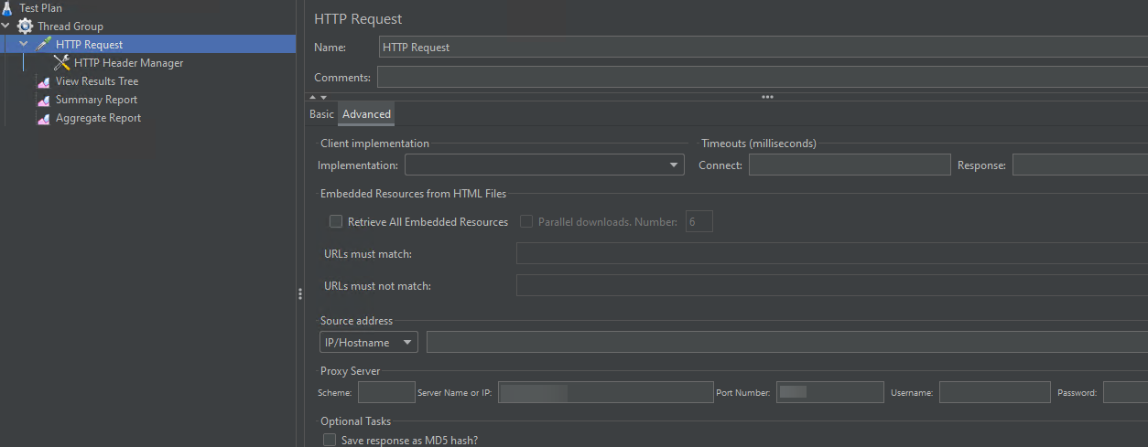

### 3.2.1 Adding HTTP Header

In the Advanced tab enter the proxy details

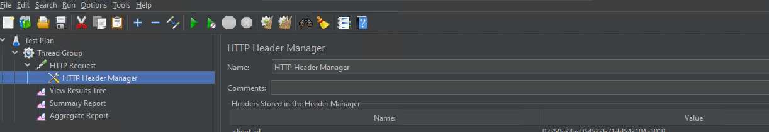

## Add Listener

To see the results of test plan, add listener named “” by navigating to *‘Right click thread group -> Add -> Listener -> View Results Tree’*.

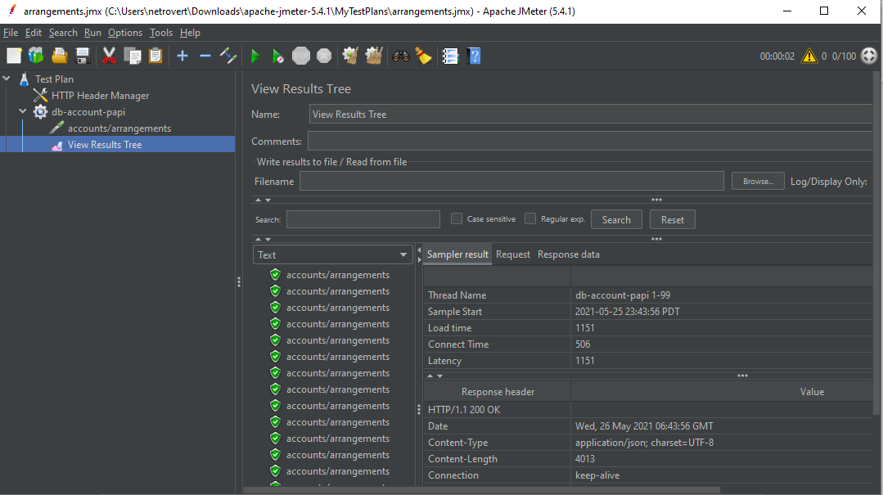

Add Listener

## Perform load testing

To perform the load testing, start the thread group using the green play icon at the top ribbon in tool.

Start Load Test

Let all threads run and invoke the configured application URL. After the test is finished, we can review the load test results in consolidated manner in listener tab.

Load testing results

